**How to run the Vehicle Breakdown Assistance Management System Django Python**

**1.** Download the zip file.

**2.** Extract the file, copy vehicleassistance folder, and paste it on the desktop.

**3.** Open MySQL Create a database vbamspythondb then import the SQL File available in the SQL File Folder (For MySQL we used the [XAMPP](https://phpgurukul.com/how-to-install-xampp/)server).

**4.** Open PyCharm and click on the terminal.

**5.** Navigate the project folder using the cd command.

cd project_path

**For ex:**cd C:\Users\ANUJ\OneDrive\Desktop\vehicleassistance\

**6.** Now Navigate to the vbams folder

cd vbams

**7.** Run the Project using the following command

python manage.py runserver

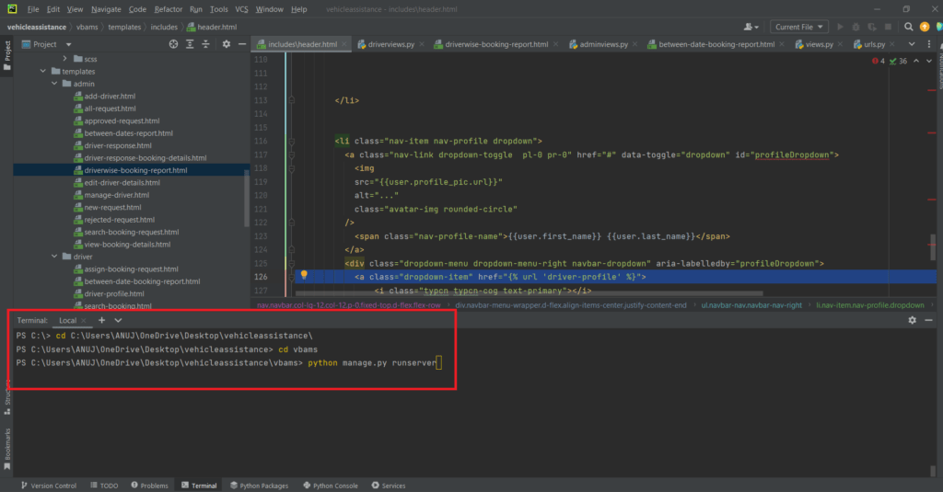

Now click the URL http://127.0.0.1:8000 and the Project will Run

**Login Details**

**\*\*\*\*\*\*\*\*\*\*\*\*\*admin\*\*\*\*\*\*\*\*\*\*\*\***

**Username:**admin

**Password:** Test@123

**\*\*\*\*\*\*\*\*\*\*\*\*\*Driver\*\*\*\*\*\*\*\*\*\*\*\***

**Username:**abir123

**Password:** Test@123 OR Register new driver